Financial Management 1st Semester Exam Review

Exam will be multiple choice and 2 essay questions covering the following material:
- Email Netiquette
- Job Applications
- Career Vocabulary
- STAR Interviewing, Professional Dress
- SMART Goals
- Entrepreneurship Vocabulary
- Figuring Hourly Pay, Salary & Commission
- Money Management Vocabulary

The Do's and Don'ts of Email Etiquette

While we try to work faster and more efficiently, we must not forget the social rules that accompany any form of communication. Here are some of the dos and don’ts of email etiquette.

Do have a clear subject line.
Most of us have to compete with the hundreds of emails clogging our inbox every day, so the clearer your subject line, the more likely your message will be read. For example, if you’re sending a proposal to someone, be specific and write, “The Fitch Proposal Is Attached.”
Don't forget your signature.
Every email should include a signature that tells the recipient who you are and how to contact you. Set it up to automatically appear at the end of each email. Include all of your contact details so the recipient doesn’t have to look up your address, email or phone number.
Do use a professional salutation.
Using “Hey,” “Yo,” or “Hiya” isn’t professional, no matter how well you know the recipient. Use “Hi” or “Hello” instead. To be more formal, use “Dear (insert name).” Using the person’s name in the salutation -- “Hello Robert” -- is quite appropriate, but remember not to shorten a person's name unless you're given permission to do so.
Don't use humor.
Humor does not translate well via email. What you think is funny has a good chance of being misinterpreted by the other party, or taken as sarcasm, without the accompanying vocal tone and facial expressions. When in doubt, leave humor out of business communications.
Do proofread your message.
Don't be surprised if you're judged by the way you compose an email. For example, if your email is littered with misspelled words and grammatical errors, you may be perceived as sloppy, careless, or even uneducated. Check your spelling, grammar and message before hitting “send.”
Don't assume the recipient knows what you are talking about.
Create your message as a stand-alone note, even if it is in response to a chain of emails. This means no “one-liners.” Include the subject and any references to previous emails, research or conversations. It can be frustrating and time consuming to look back at the chain to brush up on the context. Your recipient may have hundreds of emails coming in each day and likely won’t remember the chain of events leading up to your email.
Do reply to all emails.
Give a timely and polite reply to each legitimate email addressed to you. Even if you do not have an answer at the moment, take a second to write a response letting the sender know you received their email. Inform the sender if their email was sent to the wrong recipient, too.
Don't shoot from the lip.
Never send an angry email, or give a quick, flip response. Give your message some thoughtful consideration before sending it. If you feel angry, put your message into the “drafts” folder, and review it again later when you are calmer and have time to formulate an appropriate response.
Do keep private material confidential.
It is far too easy to share emails, even inadvertently. If you have to share highly personal or confidential information, do so in person or over the phone. Ask permission before posting sensitive material either in the body of the email or in an attachment.
Don't! over use exclamation points.
Exclamation points and other indications of excitement such as emoticons, abbreviations like LOL, and all CAPITALS do not translate well in business communications. Leave them off unless you know the recipient extremely well. It’s also not professional to use a string of exclamation points!!!!!

It may take some practice to keep your emails professional and to the point, but you will look more polished and organized in the long run.

Job Application
Be prepared to complete a job application. You will need a copy of your résumé or the information on an index card.
- Use a black ink pen
- All questions must be answered
- N/A is written when the questions do not apply to you
- Print “Negotiable” in the field for desired pay or salary
- Sign the application form
- Spelling and grammar must be accurate
- APPLICATION IS NEAT

Career Vocabulary
Study online at https://quizlet.com/148866478/career-vocabulary-flash-cards/

1. Apprentice--A person who works for another in order to learn a trade
2. Aptitude--Capacity for learning; natural ability
3. Associate's degree--a two-year degree awarded by community colleges, career schools, colleges, and universities
4. Bachelor's degree--a university or college degree received after four years of study
5. Career Cluster--A group of occupations having related interests.
6. Colleague--someone you work with, especially in a profession
7. Community college--a college that people can go to for two years to learn a skill or prepare for university
8. Doctorate--the highest level of degree given by a university
9. Employee--someone who is paid to work for a person, organization, or company
10. Employer--the person/s who pays someone to work for them
11. Graduate school--a college where you can study for a master's degree
12. Job--A work role within a specific organization which is paid or unpaid.
13. Major--the main subject that you study at a college or university
14. Master's degree--a university degree you get by studying for 2 years after your first degree
15. Minor--the second main subject that you study at a college or university
16. Occupation--A wide category of jobs with similar characteristics
17. Outsourcing--the practice of using workers, supplies, or parts from an outside company instead of producing them yourself
18. Profession--A job that needs special education or training
19. References--a person who knows you well and writes a letter containing information about you, usually to a new employer
20. Résumé--a written list and description of your education and previous jobs
21. Standard of living--A standard of living is the minimum necessities thought to be essential
22. Trade--a particular career, especially one in which you work with your hands
23.Undergraduate--a student in the first four years of college
24. University--an institution of learning of the highest level authorized to confer both undergraduate and graduate degrees
25. Vocational school--a school that teaches you the skills you need to do a particular job.

STAR Interview Technique
First, examine the question: what is its purpose; what specific skill is the question addressing? Next, choose an applicable experience. In your mind, recollect and reflect on specifics of that experience. You can structure your answer a using the four steps of the ‘STAR’ technique:
- ‘S’ for Situation: Start your answer by providing the background of your experience. Describe the circumstances of your involvement. Provide enough detail to preface the rest of your narration.
- ‘T’ for Task: Describe the challenge at hand and what needed to be done. Give the expected outcome and any conditions that needed to be satisfied.
- ‘A’ for Action: Elaborate your specific action in response to the challenge. Specify analytical work, team effort or project coordination. Use ‘I’ and ‘we’ statements as appropriate.
- ‘R’ for Results: Explain the results of your efforts: what you accomplished, what you learned, how your managers and team responded, and how your organization recognized you. Wherever possible, quantify your achievements and improvements—e. g., “20% improvement in …” or “reduced manufacturing costs by 1.5 million dollars per year …”
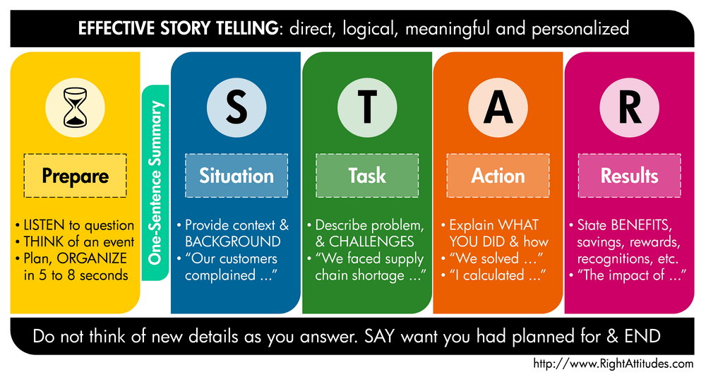

Dress for Job Interview
You should be dressed in such a manner that is acceptable and appropriate in a professional business setting. The following items constitute approved attire for all:
Men
- Dress slacks
- Button down dress shirt (tucked in) and a coordinating tie
- Belt, dress socks and dress shoes
- Sport coat or suit optional
- Sweater acceptable with a dress shirt and tie

Women
- Dress or pant suit outfit (dress no higher than two inches above knee)
- Dress slacks or skirt with a coordinating blouse or sweater
- Nylons and dress shoes

SMART Goals
Specific
- Well defined
- Clear to anyone that has a basic knowledge of the project
Measurable
- Know if the goal is obtainable and how far away completion is
- Find out when you have achieved your goal
Agreed Upon
- Agreement with all the stakeholders what the goals should be
Realistic
- Within the availability of resources, knowledge and time
Time-Based
- Enough time to achieve the goal
- Not too much time, which can affect project performance

Budgets
Study online at https://quizlet.com/237504477/budget-vocabulary-flash-cards/

Appreciate--to increase in value or price over time
Assets--anything of value owned by a person or company
Barter--trade or get things one needs or wants. People use money to make exchange easier because it is assigned specific value.
Budget--a tool that helps you plan your spending
the goal is to balance the budget to make sure income = expenses or income > expenses
Currency--type of money (United State is the U.S. dollar)
Denomination--number stamped or printed on money
Depreciate--to decrease in value or price over time.
Estimate--Guess based on past knowledge or facts
Expenses--money spent or money that goes out
The Federal Reserve--A national banking system, established in 1913, that controls the U.S. money supply and the availability of credit in the country. Distributes money.
Finances--are assets or resources in the form of money
Fixed--money that is a set or standard amount each month
Fixed Expenses--Expense that stays the same from month to month
Flexible/Varied--changes from month to month
"Hand to mouth"--an expression which means they spend whatever they earn
Income--money that comes in to you
Inflation--An increase in the general price of goods and services
Interest--additional money paid to you in exchange for the use of your money for a period of time.
Liabilities--money an individual or business owes to someone else
Personal finances--include the money you earn, spend, and save
Transaction--A money activity that changes the income because of deposit, expense deduction or transfer
Unexpected Expenses--Miscellaneous money you have not planned
U.S. Department of Treasury--Federal government agency requires that deposits of $10,000 or more must notify be to track large deposits. Prints money
Value--it has worth, desirability, or usefulness
Variable Cost--Costs of production that change as a firm's output level changes.

Writing out a Check

Worksheet attached

Checking and Banking
Study online at https://quizlet.com/192385805/checking-flash-cards/

ATM--Automatic Teller Machine. Allows a customer to get out physical currency from their account
Balance--The amount of money you have in your bank account.
Bank Statement--the bank's accounting of your transactions
Blank endorsement--allows anyone to cash a check after it's been signed
Bounced check--A check written and there is not enough money in the account to cover the check
Cancelled Check--Checks the bank has paid. They will appear on your bank statement.
Check--A written order to the bank that tells it to take a stated amount of money from your account and pay it to another.
Checkbook--Holds the checks & register to track all your transactions
Check register--A record that allows you to record all transactions for a checking account
Debit Card--Used to electronically connect to bank account & requires and PIN
Deposit--Money you put into your account.
Deposit insurance--the Federal Deposit Insurance Corporation (FDIC) insures depositor's accounts up to $250,000 per person per institution
Deposit slip--A form you fill out to credit money to your account when you make a deposit.
Outstanding check--A check that has been written but not yet deducted from the person's bank account.
Outstanding deposit--A deposit that has been made but not yet added to the person's bank account.
Overdraft protection--funds used, if you overdraw your checking account funds, to cover the check
Overdraw--To write a check or make a withdrawal when there isn't enough money in the account to pay for it.
Payee--The person to whom the check is made payable.
PIN--Personal Identification Number needed to use an ATM card.
Post-date--To write a future date on a check.
Reconciliation--The process of making adjustments and corrections to the check register so it balances with your monthly statement from the bank.
Restrictive endorsement--allows the payee only to deposit a check into his or her account
Routing numbers--Numbers on check to identify the financial institution
Signature card--A card used when opening a new account that includes name, address, birthdate, etc.
Special endorsement--allows a check to be transferred to a second party
Stop payment--when a check written to someone by mistake, this can stop the payment of the check for a charge
Voided check--A check with "VOID" written across it that make it non-negotiable.

Figuring Hourly Pay, Salary & Commission

Worksheet attached

Employee Pay and Benefits
Study online at https://quizlet.com/178222484/employee-pay-and-benefits-flash-cards/

401K--An employer sponsored retirement program
Collective bargaining--The process whereby unions and employers negotiate terms of employment.
Compressed workweek--A work schedule where you work four days, ten hours each, rather than five days, eight hours each.
Deductions--Amounts subtracted from gross pay, some required and some optional.
Federal income tax--A tax on earned and unearned income paid to the federal government.
Flextime--An arrangement of working hours that varies among employees.
Fringe benefits--Employee benefits beyond wages and salary, including health insurance, sick leave and benefits.
Gross pay--The total agreed-upon salary or pay before deductions.
Incentive pay--Encouragement plan to get employees to do more and better work.
Labor union--A group of people in the same or similar occupations, organized for the benefit of all.
Medicare--A payroll tax designed to pay for health care for senior citizens in the U.S.
Net pay--Also known as the amount of the paycheck.
Overtime--Hours worked beyond the regular straight time (forty-hour work week).
Property tax--A tax on any property such as land, buildings and motor vehicles.
Seniority--The first hired is the last fired or laid off.
Social security tax--A payroll tax to help fund a government program that helps citizens fund retirement in the U.S.
State income tax--A tax on earned and unearned income paid to the state.
Straight-time--Hours paid at regular wage, usually first 40 hours per week.
Strike--A process in which employees refuse to work until an agreement with management is reached.
Tax deferred--Income that will be taxed at a later time.
Tax exempt--Income not subject to tax at all..
Vested--A condition of having full rights to monies deposited or funds accumulated in a retirement plan.
W-2--What you receive from your employer at tax time stating your total wages for the year.
W-4--A form tells the employer the correct amount of tax to withhold from an employee's paycheck

Shopping
Study online at https://quizlet.com/348150280/shopping-vocabulary-flash-cards/

Additional 50% off--It is 50% off after the first discount is taken
Anchor Store--Usually a large chain retail operation located in a shopping center serving as the attracting force for the center.
BOGO--Buy one get one free
Brick and click--A business that has both a brick-and-mortar business and an online store.
Comparison Shopping--careful consideration of features, price and quality, "rational buying"
Cross merchandising--Retailers carry complementary goods and services to encourage shoppers to buy more
Cyber coupons--a discount code or number that can be redeemed on a website to discount purchase price
Expedited shipping--is the process of sending a parcel at a faster rate than would normally be customary
First class--Package Service is a fast, cost-effective way to ship lightweight packages weighing up to 15.99 ounces to any U.S. destination
Flash sales--temporary online sales, announced each day at about the same time, that last for a specified time and are first-come, first-served
Green Retailing--Environmentally sustainable practices
Ground service--Shipments that are generally forwarded via freight services and usually require more time to deliver
Impulse shopping--unplanned buying including little consideration of the product, "emotional buying"
Liquidate--to pay a debt and/or to eliminate
Mobile Payments--A consumer banking technology that allows you to pay bills with your mobile device using an app.
Point-of-Sale (POS) System--A computer system that maintains a record of guests' purchases and payments
Priority Mai--Flat Rate is a 1 to 3 day shipping service provided by the U.S. Postal Service (USPS) that features one flat rate for delivery of a package or envelope to its destination.
Shrinkage--Inventory losses that occur as a result of theft or deterioration.
Social Commerce--the delivery of electronic commerce activities and transactions through social computing
Subscription box--a recurring delivery of niche products as part of a marketing strategy and a method of product distribution on a subscription business model.
Subtotal--The total before the taxes are calculated or the discounts are calculated.
Total--The amount actually paid after taxes and discounts.
Webrooming--the practice of examining products online and then buying them in a store

